1.VLAN:

What is VLAN?
VLAN (Virtual Local Area Network) is a way to divide one physical network into multiple separate logical networks using a switch in Cisco Packet Tracer.
and each vlan act as a separate network even though they may share the same physical hardware. Devices in a VLAN can communicate with each other as if they are on the same physical LAN—even if they are on different switches or ports.
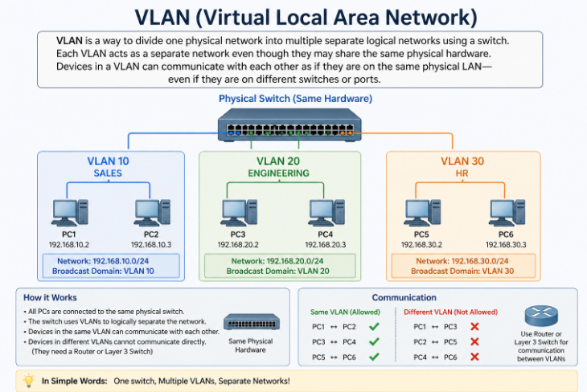
Why Do We Use VLAN?
- To segregate network traffic for security and better performance.
- To reduce broadcast traffic.
- To group users logically instead of physically.
- To provide better network management and flexibility.
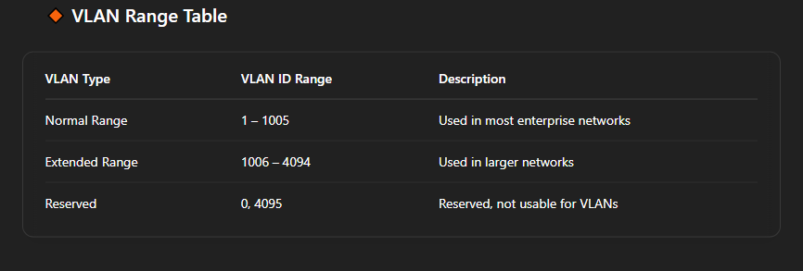

VLAN ID 0 (Simple Way)
VLAN ID 0 means traffic is sent without being part of any VLAN.

Think of it like this
- The device is not assigned to a VLAN
- But it can still send traffic
- It is mainly used to carry priority (QoS) information

One-line understanding
VLAN 0 = No VLAN membership, only priority traffic

VLAN ID 4095 (Simple Way)
VLAN ID 4095 is reserved and cannot be used by users.

Think of it like this
- It is kept by the system
- Used for internal operations
- Helps with filtering and managing VLAN traffic
- You cannot create VLAN 4095 on a switch

One-line understanding
VLAN 4095 = Reserved for system/internal use

EXAMPLE
To design and implement VLANs in a college campus network to allow multiple departments to use a common physical infrastructure while keeping their communication logically isolated for better security, manageability, and performance.

Scenario Overview
In our college campus, there are multiple departments that need to connect to the same network. However, for security and organization, we don’t want students or staff from one department accessing data from another department.

Departments (VLANs):
- Computer Science Department – VLAN 10
- Electrical Department – VLAN 20
- Administration Department – VLAN 30
These departments share one physical switch, but will be logically separated using VLANs.
Automatically Choose Connection (Auto Cable)

Simple Explanation (Base on Your VLAN Lab)

1) Network Address
- It identifies the entire network.
- It is the first IP address in the subnet.
- It cannot be assigned to a device.
In your case:
- Network: 192.168.136.0
- This represents all devices from 192.168.136.1 to 192.168.136.254 (assuming /24).

2) Gateway Address
- It is the router or Layer-3 device IP used to reach other networks.
- All PCs in the VLAN use this IP as the default gateway.
In your case:
- Gateway: 192.168.136.1
- All PCs (PC0–PC5) will use:
Default Gateway: 192.168.136.1

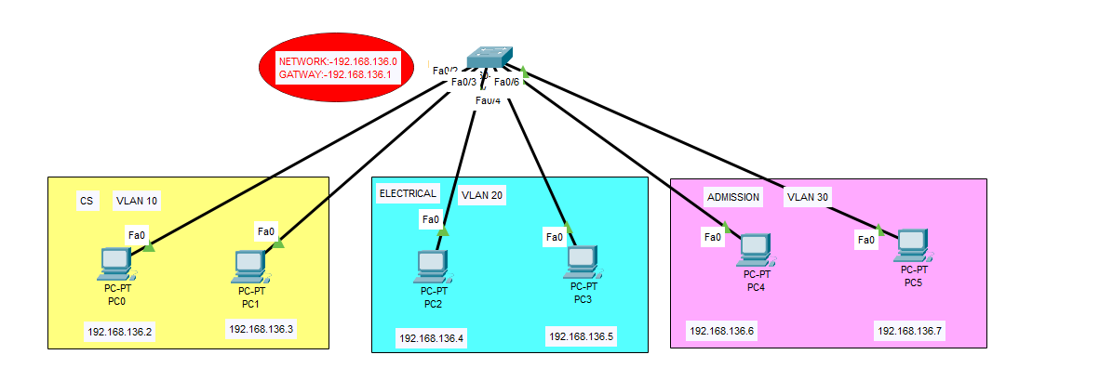

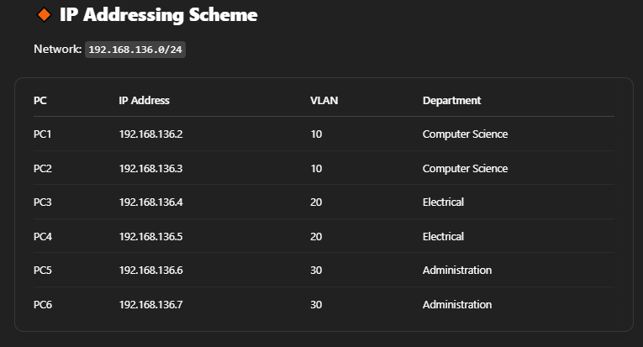

Switch Configuration (Cisco Example)
Switch>enable
Switch# conf t
# Create VLANs
Switch(config)# vlan 10
Switch(config-vlan)# name Computer_Science
Switch(config)# vlan 20
Switch(config-vlan)# name Electrical
Switch(config)# vlan 30
Switch(config-vlan)# name Administration

do show vlan brief(TO SEE VLAN INFO)

# Assign VLANs to interfaces
Switch(config)# interface fa0/1
Switch(config-if)# switchport mode access
Switch(config-if)# switchport access vlan 10

Switch(config)# interface fa0/2
Switch(config-if)# switchport mode access
Switch(config-if)# switchport access vlan 10

Switch(config)# interface fa0/3
Switch(config-if)# switchport mode access
Switch(config-if)# switchport access vlan 20

Switch(config)# interface fa0/4
Switch(config-if)# switchport mode access
Switch(config-if)# switchport access vlan 20

Switch(config)# interface fa0/5
Switch(config-if)# switchport mode access
Switch(config-if)# switchport access vlan 30

Switch(config)# interface fa0/6
Switch(config-if)# switchport mode access
Switch(config-if)# switchport access vlan 30

GIVE IP ADDRESS TO ALL PC.

Expected Output
- PC1 and PC2 (VLAN 10) can communicate with each other.
- PC3 and PC4 (VLAN 20) can communicate with each other.
- PC5 and PC6 (VLAN 30) can communicate with each other.
- Devices in different VLANs cannot talk to each other unless a Layer 3 device (router or Layer 3 switch) is used for inter-VLAN routing.

